**Microprocessor Systems and Interfacing**

**Lab Report**

**Lab03**



|  |  |
| --- | --- |
| Group Members Name & Reg #: | **Muhammad Haris Irfan**  **(FA18-BCE-090)** |
|  |  |
| Class | Microprocessor Systems and Interfacing CPE342 (**BCE-6B**) |
| Instructor’s Name | Dr. Omer Ahmad |

**Pre-Lab Tasks**

## Task-1

Students are required to read the theory section in detail. They are encouraged to address any queries with regards to the theory during your theory session.

**Task-2**

Please fill out the following table, explaining what each value for DDRx means.

|  |  |  |
| --- | --- | --- |
| **#** | **DDRx** | **Meaning** |
| 1 | DDRB = 0b1010 1010 | Pins 0, 2, 4 and 6 of port B will be inputs while pins  1, 3, 5 and 7 will act as outputs |
| 2 | DDRD = 255  0b11111111 | Pins 0,1,2,3,4,5,6,7 all are set as output. |
| 3 | DDRB = 0x0B  0b00001011 | Pins 0,1,3 are set as output and pins 2,4,5,6,7 are set as input. |
| 4 | DDRD = 0x45  0b01000101 | Pins 0,2,6 are set as output and pins 1,3,4,5,6 are set as input. |
| 5 | DDRC = 45  0b00101101 | Pins 0,2,3,5 are set as output and pins 1,4,6,7 are set as input. |
| 6 | DDRB = 0b1100 0110 | Pins 0,3,4,5 are set as input and pins 1,2,6,7 are set as output. |

## Task-3

Imagine a 7-segment display is connected to 8 pins of Port-B of an ATmega328p. The students are required to complete the contents of the following look-up table so that the numbers mentioned in the table are displayed. The task may be completed on the manual itself.

|  |  |  |  |  |  |  |  |  |  |
| --- | --- | --- | --- | --- | --- | --- | --- | --- | --- |
| Digit to be displayed | H | G | F | E | D | C | B | A |  |
| **PB7** | **PB6** | **PB5** | **PB4** | **PB3** | **PB2** | **PB1** | **PB0** | **Hex** |
| 0 | 1 | 1 | 0 | 0 | 0 | 0 | 0 | 0 | 0xC0 |
| 1 | 1 | 1 | 1 | 1 | 1 | 0 | 0 | 1 | 0xF9 |
| 2 | 1 | 0 | 1 | 0 | 0 | 1 | 0 | 0 | 0xA4 |
| 3 | 1 | 0 | 1 | 1 | 0 | 0 | 0 | 0 | 0xB0 |
| 4 | 1 | 0 | 0 | 1 | 1 | 0 | 0 | 1 | 0x99 |
| 5 | 1 | 0 | 0 | 1 | 0 | 0 | 1 | 0 | 0x92 |
| 6 | 1 | 0 | 0 | 0 | 0 | 0 | 1 | 0 | 0x82 |
| 7 | 1 | 1 | 1 | 1 | 1 | 0 | 0 | 0 | 0xF8 |
| 8 | 1 | 0 | 0 | 0 | 0 | 0 | 0 | 0 | 0x80 |
| 9 | 1 | 0 | 0 | 1 | 0 | 0 | 0 | 0 | 0x90 |

## Task-4

Once the code in Task-3 is up and running, the students are required to simulate it in Proteus after connecting 2 7-Segment displays to your ATmega328p as shown in Figure 3.7.

**In Lab Tasks**

**Task 1:**

In this task we made our circuit on the breadboard, we used PORTD and GND of Arduino Uni, the picture is given below.

____________________________

**Post Lab Tasks**

**Task 1:**

In this task, first I made the circuit on proteus and upon successful simulation I implemented the circuit on breadboard.

In the code I have used a simple nested for loop, both the inner and outer loops go from 0-9 respectively, for each value of outer loop the inner loop completes 0-9.

Port D is controlled through inner nested loop and Port C (In simulation I used PortB but on Arduino I used PortC) through outer nested for loop.

Simulation:

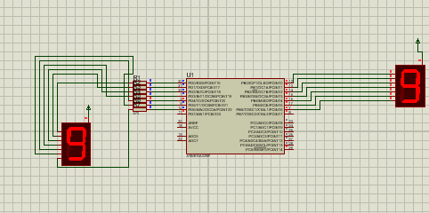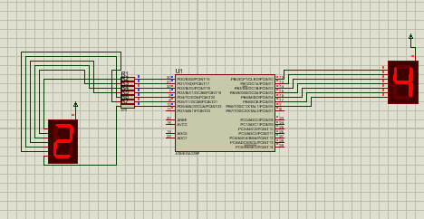

**Code**:

**Circuit:** (I used PortC and PortD)

s

_____________________________